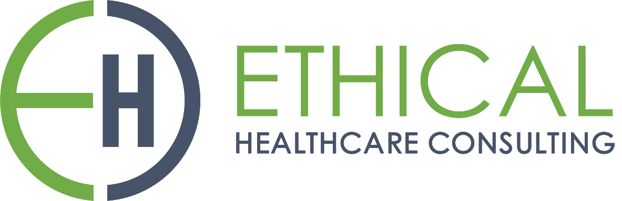

**HealthTrust Europe LLP: ITT to establish a framework agreement for consultancy solutions and advisory services Contract Notice (FTS) Ref: 2023-041574**

**Technical Response - A2_Implementation_Ethical Healthcare Consulting**

A2: Please attach an example implementation plan and explanatory narrative for the provision of a consultancy contract you have provided to a customer. This must include:

• critical points of the project;

• division of responsibilities between the each of the parties involved;

• planned milestones and deadlines and how these are monitored and communicated;

• any contingency planning processes; and

• engagement with the customer and the support offered.

This can be in the form of a Gantt Chart or equivalent critical path covering all the points.

**EHC Response:**

EHC have managed many complex programmes and we have delivered both water fall approaches and agile methodologies within our projects

The following attached supporting document examples are from our project at Southern Counties Pathology.

* ***‘SD1 Example Programme Plan’***
* ***‘SD2 Example Programme Plan Gantt Chart’***
* ***‘SD3 Example Project Board Update’***
* **critical points of the project;**

EHC helped identify critical milestones as part of the deployment of a complex programme. We did this by identifying what was the minimal viable product and safety of the system to go live with. EHC expertise recognise the importance of taking a client live with a product is crucial so that they can start the process of benefit realisation. The approach EHC take with any deployment is ensuring that a quality product/implementation is in place by ensuring key milestones and clinical safety is adhered to. This is evidenced in Slides 1- 5 in supporting documents***'SD1 Example Programme Plan’***, and within the attached ***‘SD2 Example Programme Plan Gantt Chart’****.*

Additionally, EHC recognise the need for go live/deployment confidence, therefore a gateway is also implemented to ensure EHC are on target with the deployment. This is completed by various checkpoints and critical points:

* Ensuring a governance structure is in place; escalation process, steering groups, project boards, programme boards, clinical review groups, core project team groups and sub workstream groups.
* Highlight reports are provided to ensure key stakeholders are kept up to date and informed
* Tracking of the programme against the plan and confidence gateways are in place.
  + A confidence gateway for go live is how EHC can illustrate whether any corrections are required to take place. A set number of criteria are identified to ensure the project/programme is on target for the go live date. Such examples of a LIMs implementation include; analyser connectivity, integration connectivity, percentage of testing completed, data migration validation percentage completed.
* ‘Show and Tell' sessions are implemented during the project to demonstrate progress of critical points of the project to the client and ensure EHC implement any corrective actions.
* Tools such as MS Project is used to help identify the critical points within the project and ensuring the pathway to go live is adhered to. EHC also utilise alternate tools such as Jira, to facilitate project management, including task tracking, issue management, reporting, and agile project management capabilities.
* Teams were created to focus on the build, testing and promoting items to the production environment. EHC team had focused intensive workshops, where the team focused on a set of criteria to build and test allow the client to meet the objective of a single LIMs solution.
* **division of responsibilities between the each of the parties involved;**

Roles and responsibilities are established at the client kick off meeting and stakeholder maps confirmed and developed.

EHC experience of projects ensures the appropriate governance is in place from the client and EHC side. Depending on the type of project EHC from the outset provides a governance structure to ensure the success of the project. Such examples of governance structures:

* LIMS implementation:
  + Senior Responsible Officer (SRO), clinical director, programme director, programme manager, project managers, workstream leads, testing, communication, training, clinical safety officer, quality, technical leads, key stakeholder who need to be informed
* For our smaller projects:
  + SRO, project lead, as a point of escalation, subject matter expert support, key stakeholders would need to be informed.
  + As part of our kick off meeting we ensure we establish the roles and responsibilities within the project. This is made clear with both EHC and the client and appropriate meetings are put in place to ensure the right governance is adhered too.

A roles and responsibilities document is shared with the project team to ensure we have clear expectations and jointly agreed understanding of team roles.

* **planned milestones and deadlines and how these are monitored and communicated;**

We maintain planned milestones and deadlines through our PMO toolkit's built-in tracker, which triggers reminders and contract adherence checks; milestones are also integrated into project plans, and CMAP serves as an additional operations tool for milestone tracking and reminders. Highlights of the tools available within the EHC PMO toolkit can be found within our supporting documents ***‘SD18 PMO Toolkit’****.*

EHC communicates these milestones and deadlines through regular reviews with the project teams and project boards continuously, as well as formally at the ‘show and tell’ session. An example of a Project Board report can be found within our supporting documents ***‘SD3 Example Project Board Update’****.*

* **any contingency planning processes;**

Contingency is an integral part of our project planning process, tailored to the project's identified risks, which is actively managed through sprint planning sessions or, in the case of a waterfall approach, planning workshops; contingency plans are formally approved during project governance meetings, including project boards.

For our larger complex programmes EHC provides a business impact analysis, where we analyse and predict the consequences of disruption and ensure the appropriate recovery plans are in place. An example of this is within a programme deploying a complex LIMs solution across a large network of Trusts. Contingency plans were completed from the outset due to the number of unknown challenges which were identified during the implementation as it was not the standard deployment that the supplier had previously done. Planning with the supplier and the client was key to ensuring contingency was included in the plan, sign off from the project board and additional funds were made available to support the contingency plans, should they need to be implemented. Moreover, gateways were identified as to when the contingency plan would be invoked which was done by measuring deployment progress against the plan that was created.

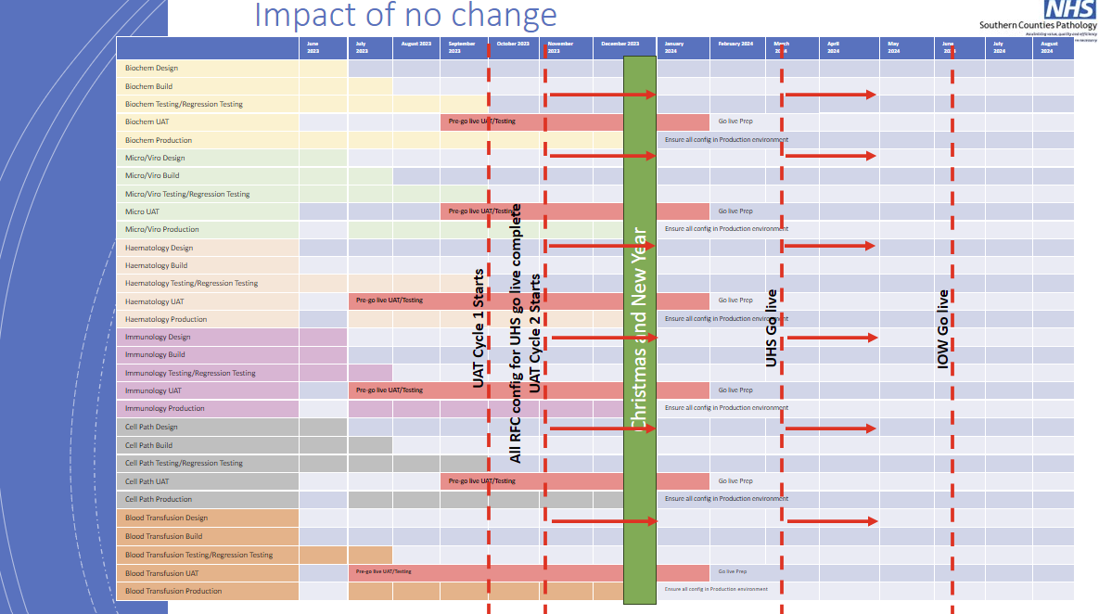

This can be evidenced and found within our supporting documents *‘****SD3 Example Project Board Update****’.*

* **engagement with the customer and the support offered.**

Our approach to customer engagement and support during implementation is represented by a commitment to enabling self-sufficiency and addressing any potential gaps in project teams. To achieve this, we maintain open and transparent communication with our clients through various reporting mechanisms such as Highlight reports, Project board reports, and Programme board reports. These reports, along with Gantt charts and burn-down rates extracted from Jira, provide our clients with a clear view of project progress and key milestones.

From the very beginning of a project, we establish a robust governance process that involves project boards, steering groups, clinical working groups, and a dedicated communication workstream. This comprehensive governance structure ensures that critical decisions are communicated effectively and that all key stakeholders are well-informed throughout the implementation phase.

Regarding supporting teams to learn and achieve self-sufficiency, we prioritise this aspect during project kick-off. We assess the skills and teams available, both from our side at EHC and the client's side. If there are areas where additional support is needed, our philosophy is to provide the necessary assistance while also empowering the client to independently continue with the project once our tasks are completed.

In cases where gaps are identified within the project team, we take proactive measures. This might involve repurposing time and resources to address immediate needs or engaging in discussions on how to recruit additional resources. Such actions may trigger scope reviews and other project management processes to ensure that the project remains on track and aligned with the client's objectives.

Overall, our approach is grounded in collaboration, transparency, and a strong commitment to not only delivering successful projects but also leaving our clients well-equipped and self-sufficient for future endeavours.

As an illustration from one of our contracts, we have included a slide showcasing the engagements of different stakeholder groups.

